西蒙

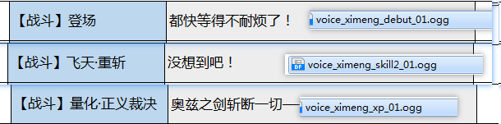

  

温丽

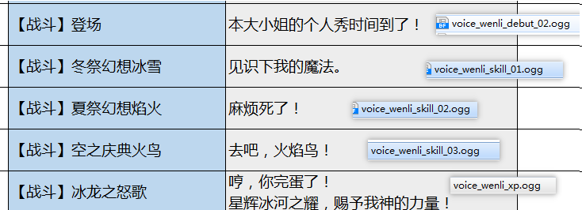

  9ec58c5b81ef5400a34eda27cc83246d a12ee0e4e0f9d84f2055ecd864a41b09 aa86ba8903dc51887339c3b202467019

爱琳娜

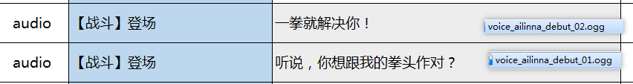

902441af3281957a105d689309bfba5e 7a333e859a1fd55134bb3de99f99100d

兰奇

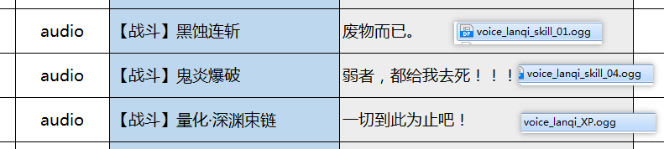

91f44af1e213434c331f262e475e3a88 df4c28b0592f0ff1835929a7bff6edc6 3af61e2b1c8cacb5ad2ecc38ccfe14db

葛莱蒂丝

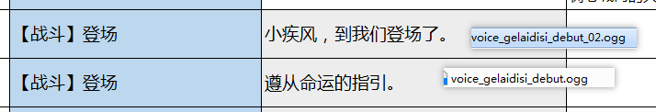

6f29840ab3f059b5e84e0b8e2f557446 b4b72cc3294e8e136c2caeb23551e229

艾琪：

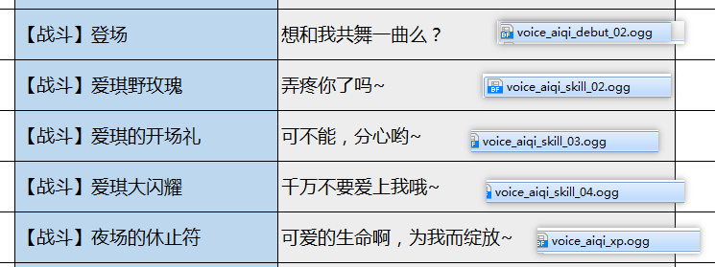

31c6380f4a7492c8db67c385008af024 5b78c7db88d2343426ead9c9084f2f00 b59cb6131be6b96552d142ac2ec14225 02a40c397ccf3f3a6390cfd7c1100b31 92577ca47b5738ada97ee4d2e63f5f83

木阐

93fde541095556188e61593902f06807

57d2f6790e664964a875cb46b6204397

泰雷：



4779b4b517558c7bc1ea47a01cc99a54

乔伊

b8869edf0c981a86fd2d2908c3f8f506

7e84388e8c3c9644f30d9fd70c53fab7

烟鬼：

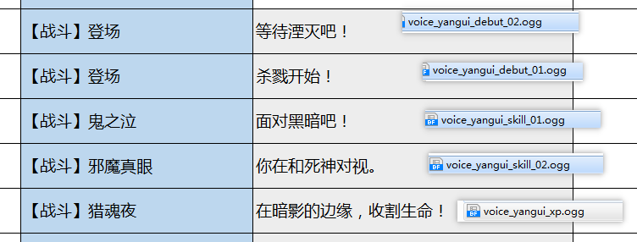

83c78e24ae523c90349bc24c7b08bdb4 8b0bd1492f40af332c038ed9e1b5555d 8f091bb2fa44d8953f7920b4935f7478 b25511dd3dfaa2064405736627ed5293 193b8e132bc7400c2a84e2426b000182

该隐：

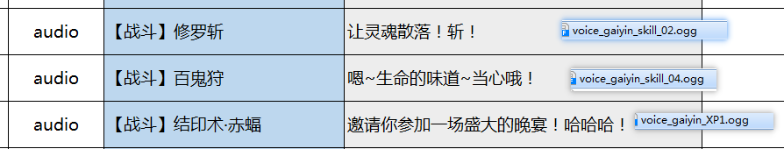

be8e553b5e8db34e44031314c9945c2d 3957ad9c7443ad21016892d6306b6c0a e1a080adbd623a471562a843ddfc11e5

米兰达：

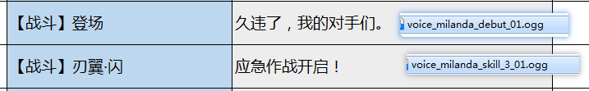

8ece97e490923eb6465c59466df22b4e e201a049b13a1e43a40fd638b7694f1e

那他那



33b712448a4c11178efba9eb83e5bbac

6a5203f099d18827b4ff9afe8f3a8f94 61f02846d07888a272757532374e29c1

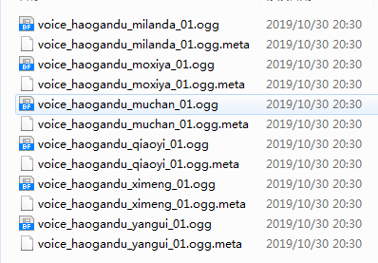

5451da6c5112ed97b1fd80876d0ba014 771f2716bf8c2d3f87060c3484561a19 688b4426a002b7cad8cffa1017f4fc59 fd3077ecf0f63ef4b8480407d0db7777 f330cd82f34bce5f5bf1a35024071995 1c3492c033abf479c91a37c470c244f9